
Hello, Penn-Jersey, and welcome to the Summer 2018 newsletter. In this edition, you’ll find information on the following:
- What’s New
- Newsroom - Government Affairs
- OSHA Quick Takes
- Howard Talks Tech
President’s Message to Chapter
Greetings. As the new President, I’m both excited and anxious for a year of change, starting with the Safety Professionals name change. As a military veteran, I’m encouraged by the new members joining our group from the McGuire-Lakehurst-Dix Joint Base area. I look forward to working with all of you for a successful chapter year.

Cindy Baldwin, CSP
President, ASSP Penn-Jersey

What’s New
OSHA News:

U.S. Department of Labor Extends Some Compliance Dates For General Industry Beryllium Standard
Final rule of OSHA extends until Dec. 12, 2018, the compliance date for certain ancillary requirements of the general industry beryllium standard that were finalized on Jan. 9, 2017 (82 FR 2470). The rule extends the compliance date for provisions related to methods of compliance, beryllium work areas, regulated areas, personal protective clothing and equipment, hygiene areas and practices, housekeeping, hazard communication, and recordkeeping. The rule does not affect the May 11, 2018, compliance date for new permissible exposure limits for general industry, construction, and shipyards or the general industry provisions for exposure assessment, respiratory protection, medical surveillance, and medical removal. The rule also does not extend the March 11, 2019, compliance date for provisions on change rooms and showers (hygiene areas and practices) or the March 10, 2020, compliance date for implementation of certain engineering controls.

Did You Know? OSHA’s top 5 most popular publications can be downloaded free of charge at www.osha.gov/publications.

ASSP Local Chapter News:

New Board Members
Congratulations to the incoming board members:

- President – Cynthia Baldwin, CSP
- Vice President – Howard Spencer, CSP
- Treasurer – David Guirguess, CSP
- Secretary – Kelly States, CSP
- Delegate - Danielle DiGironimo, CSP

PLATINUM LEVEL Award
Our chapter received Platinum Level for the year 2016-2017. Chapter President Mike McGowan received the award at ASSP 2018.

Safety Professional of the Year (SPY) Awards
Do you know a chapter member you feel should be recognized for their dedication to the Safety Profession? Nominations should be sent to past-president@penn-jersey.assp.org by September 30th.

Howard Talks Tech
Check out the latest Howard Talks Tech written by our very own Howard Spencer. These articles are perfect discussion starters that are useful in guiding others to safety so please take a moment and explore the collection of topics.

 If you are currently signed-up for LinkedIn don't forget to connect with the ASSE Penn-Jersey Chapter network. We have 61 members and counting! Will you be the next member?

Chapter Technical Meeting:

Your ASSP Executive Board is working on lining up interesting technical topics for the year 2018-2019. Our technical sessions are normally held the second Tuesday of the month which includes dinner at Villa Mannino’s, 73 US-130, Bordentown, NJ. The programs start at 6 pm. Check out our chapter website for more information and registration.

Our first technical session this fall will be held on September 18, 2018. The topic will be on Mindfulness in the Workplace. Significance of establishing mindfulness is growing to change/improve safety culture of organization.
This will be presented by Ms. Katherine Knodel, speaker and workshop leader, writer, leadership consultant, spiritual director, and transformational training designer, works with groups to help them empower the life and mission of their organizations and with individuals to heal and empower their lives. She is certified in Transformational Training Design and Empowerment Facilitation through The Empowerment Institute School of Social Transformation and has taught mindfulness and other centering practices for 25 years.

We look forward to seeing you in September.

App of the Month

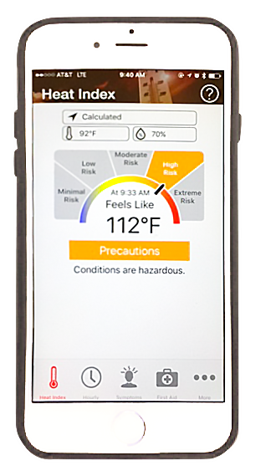 OSHA-NIOSH Heat Safety Tool App

The OSHA-NIOSH Heat Safety Tool is a useful resource for planning outdoor work activities based on how hot it feels throughout the day. Featuring real-time heat index and hourly forecasts, specific to your location, as well as occupational safety and health recommendations from OSHA and NIOSH.
The OSHA-NIOSH Heat Safety Tool features:
- A visual indicator of the current heat index and associated risk levels specific to your current geographical location
- Precautionary recommendations specific to heat index-associated risk levels
- An interactive, hourly forecast of heat index values, risk level, and recommendations for planning outdoor work activities in advance
- Editable location, temperature, and humidity controls for calculation of variable conditions
- Signs and symptoms and first aid information for heat-related illnesses

This free App is available on apple or android platforms.(source: https://www.cdc.gov/niosh/topics/heatstress/heatapp.html?s_cid=3ni7d2XHST-Heat-App-05.2017)

Have Something to Share with the Chapter?
Contact our newsletter editor Dhruti Thaker @ dthaker@oled.com.

