Understanding Class K Fire Extinguishers
Before the 1990s, grease fires were often treated with dry chemical extinguishers or, in earlier, more dangerous times, with water or baking soda, which often resulted in dangerous flare-ups.
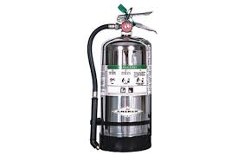
As modern, commercial cooking appliances became more efficient, they used vegetable fat instead of animal fat and thus burned at higher temperatures, necessitating a specialized, dedicated extinguishing method to prevent re-ignition. Class K fires involve flammable liquids, like Class B fires, but are specifically related to food service and the restaurant industry. Since this class of fire burns hotter than typical class B fires, the extinguishing methods used for B flames will not work on K flames. Class K fire extinguishers were developed to tackle the high-energy, stubborn cooking fats.
How They Work: They release a fine, wet mist that cools the hot oil/appliance, suppresses flames, and seals the surface, preventing re-ignition.
Badger pioneered wet chemical technology for commercial kitchens around 1997, which became the standard for Class K, which is for vegetable oil, animal fat, and trans-fat fires.
Class K fire extinguishers use a wet potassium-based agent that creates soapy foam on the surface of the fat, cooling the oil and preventing oxygen from feeding the fire (a process known as saponification).
- Saponification is the chemical reaction, specifically alkaline hydrolysis, which produces soap and glycerol by reacting to fats or oils (triglycerides) with a powerful base, such as sodium hydroxide (NaOH) or potassium hydroxide (KOH). The process breaks down fatty esters, creating carboxylate salts (soap) and glycerol.
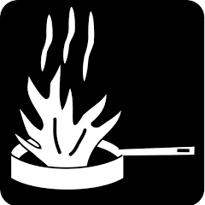
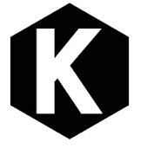
Class K fire extinguishers are essential for areas at risk of fires from cooking oils and fats. NFPA 10 - 6.6. 2 - Maximum travel distance shall not exceed 30 ft from the hazard to the extinguishers. Class K extinguishers are now required for commercial kitchens, featuring a black hexagon symbol for identification, often accompanied by a pictogram of a frying pan with flames.
Class K fire extinguishers do not have numerical ratings (like 2-A:10-B: C) because they are assessed against a single, standard, large-volume cooking oil fire rather than varying, smaller sizes.
Pass/Fail Testing: Instead of a numerical rating, these extinguishers pass a test if they can successfully extinguish a deep-fat fryer fire without causing splashing or re-ignition. While they lack a rating number, their effectiveness depends on the physical size of the cooking equipment, with NFPA standards guiding appropriate selection for commercial kitchens.
Only use Class K extinguishers after the automatic fire suppression system has operated and after the energy source. s (gas/electric) are turned off. Only attempt to fight a fire if it is small, contained, and you have a clear exit path. Pull the pin. Aim at the base of the fire. (10-12 feet away), Squeeze the lever, and Sweep side-to-side.

