**Understanding cut-resistant gloves**

Cut-resistant gloves (CRG) are fundamental personal protective equipment (PPE) for many jobs. They are the last line of defense between an identified hazard and the end user. These are gloves that ***resist*** being cut. According to a recent OSHA study, **70.9%** of hand injuries could have been prevented with safety gloves. They provide a barrier between the hand and the cutting sharp. But they are **not** *cut-proof. A cut-resistant glove will provide some protection but will not stop all cuts.*

Gloves get their cut resistance rating by undergoing a test under artificial conditions. The approved testing methods determine how much force is required to cut through the glove’s material.

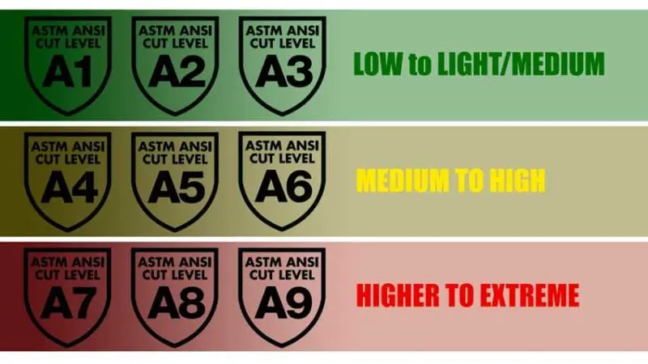These tests do not reflect real-world industrial situations, applications, or conditions. Still, they are the best method currently available for testing cut resistance. At least three cut resistance testing methods are currently in use. In America, the [ANSI/ISEA 105](https://webstore.ansi.org/standards/isea/ansiisea1052016) methodology and the descriptors are valid for use in the glove selection process. [ANSI](https://www.safeopedia.com/definition/19/american-national-standards-institute-ansi) ranks the level of cut resistance from A1 to A9. *A higher number indicates that the glove material resisted a higher level of cutting force during testing.*

Consult suppliers and manufacturers. Ask people in industries like yours and seek their advice on selecting the right style and rating. Get the safety committee involved. They can speak to a variety of concerns beyond the cut resistance level. An excellent source of additional information can be found at: <https://www.ishn.com/ext/resources/Resources/ebooks/ISHN-r6092616.pdf>