Hello, Penn-Jersey, and welcome to the November 2019 newsletter. In this edition, you’ll find information on the following:
- What’s New
- Upcoming Events
- Newsroom - Government Affairs
- OSHA Quick Takes
- Howard Talks Tech
PRESIDENTS MESSAGE
I’d like to wish my fellow veterans a Happy Veterans Day and say thank you for your service. I look forward to networking with you at our next meeting.
Cindy Baldwin, Chapter President

CHAPTER NEWS
NOVEMBER MEETING – This will be a recognition and networking dinner meeting. We have invited our Past Chapter Presidents to attend and hope to have open discussions about what has kept them involved in our profession. Please bring any topics or concerns from your industry to search for ideas and answers to the things that haunt you. The meeting will be held on Nov 19th stating at 6 pm, Villa Mannino’s in Bordentown, NJ. Please register for the free dinner at our website https://penn-jersey.assp.org/ for an accurate head count.

The Chapter hosted a TECHNICAL TOUR at The Tacony Palmyra Bridge. On October 23rd eight of our members were escorted by Patrick Reilly, Jr / Dir Public Safety, Burlington County Bridge Commission. We visited the control room and observed an opening from on the span. It was fascinating to see the two halves of the bridge which weigh 5.5 million pounds be hoisted up at a steep angle simply by a series of gears. No Hydraulics involved. All this with the original 1929 equipment!
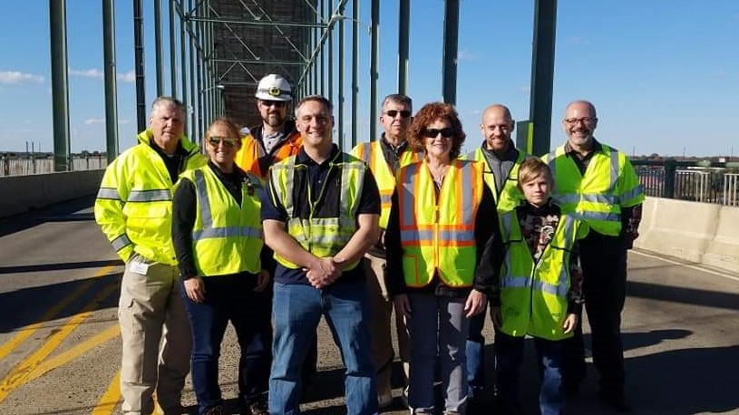

ASSP RECOGNITION
Shout out to the following Service award Recipients:
25 Years 40 Years
Matthew Clifford Scott Fellows
David Rose Jan Young
Colleen Drahuschak
Robert Reager
Mathew Swan

GOVERNMENT AFFAIRS An important deadline is approaching
NHTSA issues Federal Motor Vehicle Safety Standards (FMVSS) to implement laws from Congress. DOT Rule 49 CFR Part 40 Section 40.3.
First Requirement: Every company covered by Department of Transportation regulations that employs safety-sensitive employees must have one (or more) Designated Employer Representative (DER). This is an important position. First off, it's required by DOT. A DER is also necessary for any non-DOT employer who has someone managing their drug testing program. This person is typically from the human resources or safety department. The role of the DER cannot be outsourced. DOT states the employer may not delegate the DER role to a service agent. Only the employer or an actual employee of the employer may perform this function.
Second Requirement: The Federal Motor Carrier Administration (FMCSA) has established the Commercial Driver’s License (CDL) Drug and Alcohol Clearinghouse (Clearinghouse). This new database will contain information pertaining to violations of the U.S. Department of Transportation (DOT) controlled substances (drug) and alcohol testing program for holders of CDLs.
The Clearinghouse rule requires FMCSA-regulated employers, Medical Review Officers (MROs), Substance Abuse Professionals (SAPs), consortia/third party administrators (C/TPAs), and other service agents to report to the Clearinghouse information related to violations of the drug and alcohol regulations. All motor carriers must comply with the deadline of Jan. 6, 2020.
There is an updated proposal that would give state agencies until Jan. 6, 2023 before they are required to request clearinghouse information before completing certain commercial driver's license (CDL) transactions.

OSHA NEWS The U.S. Department of Labor's Occupational Safety and Health Administration (OSHA) has launched a new program to address hazards associated with exposure to high levels of occupational noise. This Regional Emphasis Program (REP) focuses on workplaces with the highest expected exposure to noise, a hearing loss incident rate of 15.0 and above per 100,000 full time workers. The REP is effective in the states of New York, New Jersey, Puerto Rico (limited to sites under federal jurisdiction), and the U.S. Virgin Islands. The REP document is posted at https://www.osha.gov/enforcement/directives/lep.

The program begins October 1, 2019, with a three-month period of education and prevention outreach to encourage employers to bring their facilities into compliance with OSHA standards. Enforcement activities directly related to the REP will begin after the outreach period and OSHA will continue to respond to complaints, referrals, hospitalizations, and fatalities throughout.

Exposure to occupational noise can cause noise-induced hearing loss that can be either temporary or permanent. High noise levels can also cause sensitivity, tinnitus, and acoustical trauma. Hearing loss is pervasive but it is also preventable with the implementation of proper controls. Proper controls can consist of engineering controls (e.g., mufflers, isolation from the noise source, or acoustic baffles), administrative controls (e.g., employee rotation and limiting duration of exposure), or personal protective equipment (i.e., hearing protectors) if engineering controls or administrative controls are not feasible.

For additional information about how to protect workers where noise levels are unable to be reduced below the OSHA required levels, please see https://www.osha.gov/SLTC/noisehearingconservation/.

