What is Caution?
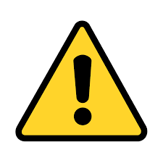
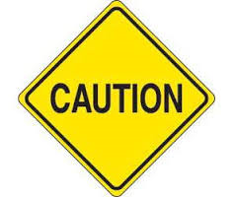
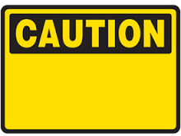
Meriam Webster defines “Caution” as care taken to avoid danger or risk. Careful (meticulous, scrupulous, punctilious mean showing close attention to detail) attention to the probable effects of an act. Various symbols are used to alert us to the need for caution. The yellow diamond on point sign is used on Highways to alert drivers to a minor hazard that may not be obvious. The yellow rectangle is used in industry to draw attention to a hazard in the workplace. I believe it is designed to trigger an action of looking for a hazard. Or it could be that to avoid injury we need to do something wise or responsive. All meanings call for cognitive behavior. The thinking about the consequences of our actions in regard to the new knowledge of a hazard’s existence is the essence of cautious behavior. But is the link between the hazard and our awareness of it, automatically clear-up the adverse consequences? Or by being promptly notified is the correct preventative action obvious?
What characterizes a “cautious” action? A caution action is careful, well considered and sometimes slow or uncertain.
The Huffington Post in an article published on November 17, 2011; in my opinion makes a strong point relevant to our discussion. The adjectives that we use to describe ourselves, set the tone for our decision-making. “The difference between cautious and careful is that cautious is an emotion, a fear based emotion at that. Being careful is an action; they’re things you can do, like gathering data, getting additional input, studying experts, etc. Being cautious can make you afraid, but being careful can make you confident.” Asking people to be cautious stalls decision-making. Asking them to be careful gets them more engaged.
I ask you to consider this; cautious is good, but only if it causes us to stop and pay attention to the probable effects of a soon to be undertaken act. We must first recognize the hazard and then decide to take an action you now feel confident will keep you safe. The warning is not enough! Somehow, we have to share the knowledge of best practices that makes the completion of a task in a safe manner likely. I believe, the key to safety is for each of us to have access to enough timely knowledge to allow a thoughtful decision. When this works we can have confidence that our careful decision will lead to cautions behavior. Any thoughts?

