Difference between Area of Refuge and Shelter in place
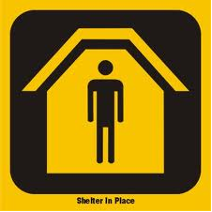
Deciding whether, and how, to evacuate depends on the type of threat, the circumstances of the threat, and where the danger is or is suspected to be. Evacuation of an entire facility or area may not always be prudent, especially if evacuation may lead to other risks by taking the occupants out of the physically secure environment of the facility and onto the streets. One of the instructions you may be given in an emergency where hazardous materials may have been released into the atmosphere is to shelter-in-place.
At the very least, every facility should develop and implement an emergency plan for protecting employees, visitors, contractors in the facility. This plan is called “protective actions for life safety” and includes building evacuation (“fire drills”), sheltering in an area of refuge from severe weather such as tornadoes, “shelter-in-place” from an exterior airborne hazard such as a chemical release and lockdown. Lockdown is protective action when faced with an act of violence. Shelter-in-place and areas of refuge are often thought about as similar. While there are similarities there is also a distinction between the two terms which safety practitioners need to understand.
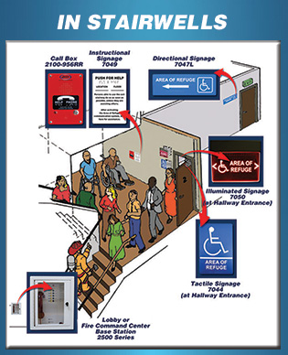
What is Shelter-in-Place: a precaution aimed to keep you safe while remaining indoors. Shelter-in-place means selecting an interior area, & taking refuge there. It does not mean sealing off the entire building. A host of new mandates came about as a result of the World Trade Center attacks and awareness of fire-prevention and egress as a result of The Station Nightclub fire in Rhode Island during the early part of this decade.
One of the more interesting developments is annexes by NFPA. These annexes are attached to a range of standards; include NFPA 101, Life Safety Code. The NFPA 101 spokesperson stated, “The thing to remember is that the front of the model codes is mandates. Annexes are at back, which are advisory in nature.”
Area of refuge is defined as: a location in a building designed to hold occupants during a fire or other emergency, when evacuation may not be safe or possible. Occupants can wait there until rescued ….by firefighters. The International Building Code lists several criteria:
- 1007.6.1 Size. Each area of refuge shall be sized to accommodate 1 wheelchair space of 30“by 48“for each 200 occupants or portion thereof.
- 1007.6.2 Separation. Each area of refuge shall be separated from the remainder of the story by a smoke barrier ….or a horizontal exit ….. Each shall be designed to minimize the intrusion of smoke.
- 1016.1. Every required area of refuge shall have direct access to a stairway.

If Evacuating: Exit the building and move directly to your assembly area. Use caution when walking into the street because oncoming traffic may be unaware that the building is being evacuated. Once at the assembly area, report to your supervisor or site leader, remain quiet, and stay with your group.

