Understanding Switchboard Matting
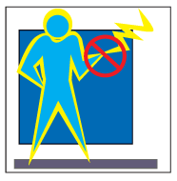
For the protection of the operator, where parts of more than 50 volts to ground are not guarded or isolated by elevation, insulating mats providing good footing shall be so placed that the operator cannot readily touch the live parts unless standing on the mat. These mats may also provide anti-fatigue for persons who must stand for long periods of time reading gauges, taking readings or operating controls. Insulating matting should not be confused with rubber or carpet runners used to help prevent slips and falls. They should not be relied upon as the sole or primary source of electrical insulation.
Dielectric matting most commonly called Switchboard matting is placed on the floor to insulate personnel from electrical shock. PEOSHA states that “Dielectric matting must be used when appropriate to protect all personnel from electrical hazards [29 CFR1910.335 (a) (2) (ii)].” The US-MSA also recommends that, “insulated mats or platforms, insulated for the phase-to-phase voltage of the system, shall be kept in place at all switchboards & power control switches where shock hazards exist.”
Matting used for electrical insulation should meet either of the two common standards.
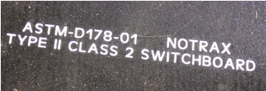
- ASTM D-178, Class 2 Type II
Type II includes: A - Ozone Resistance
B - Flame Resistance
C - Oil Resistance
- Mil Spec 15562-F Amend. 3, Type II.
Mats meeting the standards are made from rubber, 1/4" thick and selected according to the voltage.
Class | Maximum Use Voltage
0 | 1,000
1 | 7,500
2 | 17,000
3 | 26,500
4 | 36,000

The various surface textures available act as a safety tread while reducing the possibility of metal particles becoming imbedded. All mat classes are available in various widths and up to 60' continuous lengths. Switchboard matting must be stamped on the reverse every 40” with identification coding, (manufacture’s name, type, class, & ASTM D-178)

Non conductive floor mats come in three variants - non-conductive corrugated, non-conductive smooth and non-conductive diamond plate matting. The choice is based on the application. When personnel are working with exposed, energized parts, the dielectric matting must:
- Be placed around test benches & equipment, such as switchgear and elevator control rooms, during maintenance such that personnel are standing only on the matting while working.
- Be used in addition to all other PPE that is required by OSHA.
- Be inspected regularly to ensure that it is not damaged.
- Vacuumed or swept frequently to remove debris that may imbed in the mat.

Mats should be carefully inspected before work is done which may require their protection

