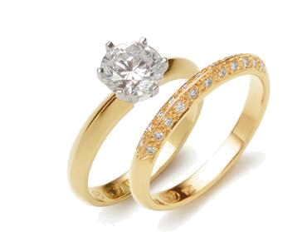
The Hazards of Jewelry on the job

During the Medieval period is when rings became popular. All classes of people wore rings from the poorest to the richest. Rings were typically made of iron, copper, silver, and gold. The material of the ring worn usually indicated the class of the wearer. It has been traditional for woman to wear wedding rings and there are records of an exchange of rings at wedding ceremonies back to the times of ancient Egypt. It was rare for a man to wear a wedding ring after the marriage until after World War II.
Rings are nice, but electricians and many other workers should not wear them on the job. A metal ring has very low resistance and can carry huge currents even at low voltages. The man's finger could be burned right off his hand from even a low voltage; 6-volt supply. The same concern exists with other piercings of the lip, cheek or eyebrow. It is estimated that nearly 5 - 10% of the American population has had some form of body piercing done. In addition to the electrical and snag issues if contaminated jewelry pieces or instruments are used, there is a risk of contracting Hepatitis B or C or tetanus.

In daily life, taking every accident cause or degree of severity into account, hand accident circumstances are extremely varied. Accidents due to wearing rings and wedding bands seldom occur in “high-risk” situations (using cutting machines or violent sports) but on the contrary during routine situations of life (doing office work, closing a car door, falling, getting caught on fencing, falling from a stool). There are twice as many male victims as female victims.

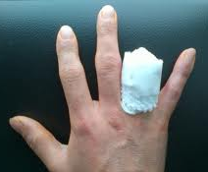
Injuries to fingers caused by wearing rings and wedding bands are among the most severe hand accidents and are the hardest to treat. Actually, a finger sheared by a sharp object causes local vascular lesions that can be repaired by a mere suture; success rate is at roughly 70%. The traction of the forceful removal of a ring from a finger causes tissue avulsion. Nerves, vessels, tendons and the osteoarticular system, (pertaining to or affecting bones and joints) do not have the same tear level, leading to partial or total “degloving” of the finger depending on what the ring is made of, how it fits the finger, the degree of violence and angle of the movement.

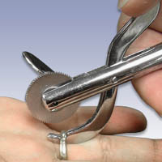
For others for whom wearing wedding rings is a challenge or a danger, they should simply slip the ring off and place it on a chain around their necks while they are work. This allows them to still be wearing their wedding ring, but in a way that is not as dangerous

A ring cutter is a tool that has a diamond dust impregnated saw toothed blade that is designed to cut through metals of all sorts. Most emergency rooms have these tools, or tools that are similar, so do not worry about them cutting your finger off to remove your ring. Every employer should develop a jewelry program based on an analysis of the hazards particular to their worksite.

