What do you Really Know about Acetylene?
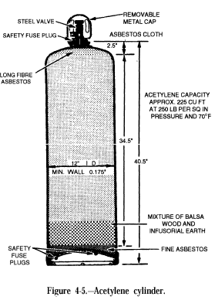
Acetylene is a widely used gas with several very unusual properties. All cylinders must be regarded as pressure vessels. The gas itself is chemically unstable, which makes it very sensitive to excess pressure, temperature, static electricity, or mechanical shock. Exposure to any of these can cause it to undergo a violent, explosive decomposition reaction. If this reaction or ignition occurs within the torch or hose, it can propagate back into the cylinder causing it to explode violently. OSHA revised its acetylene standard effective Nov. 9, 2009. Only 20% of acetylene production in the US is used for oxyacetylene cutting, & welding. The rest is used as a chemical intermediate.
Acetylene is highly flammable and lighter than air. When burned with oxygen, it produces a very hot flame that can reach temperatures between 5,700 - 6,300°F. It burns in air with a luminous smoky flame. The flammability limits in air are between 2.5 - 82% by volume. Acetylene is spontaneously combustible in air at pressures above 15 psig. It has a disagreeable odor that is readily detected.
An acetylene cylinder has a different design from other gas cylinders. It consists of a steel shell containing a porous mass which is a cellular structure that completely fills the cylinder. The acetylene gas is dissolved in Acetone which is absorbed by the porous mass. Decomposition of the acetylene is usually triggered by heat.
Acetylene cylinders are protected by a fusible plug located at the top and the bottom of the cylinder. The plugs melt at approximately 212°F or release at 500 psi. When a cylinder is overheated, the plug will melt permitting the acetylene to escape before a dangerous pressure can build up. The vent hole is too small to permit a flame to burn back into the cylinder if the gas is ignited. Acetylene can easily be ignited by static electricity; therefore, plastic piping should not used in its transmission.
Acetylene is a narcotic and was once used as a surgical anesthetic. It is a simple asphyxiant, diluting O₂ in the air. Prior to reaching levels for asphyxiation the LEL will have been reached which is a far more serious hazard! Here are a few of the commonly recommended precautions:
- Always store and use acetylene cylinders in an upright position to prevent loss of acetone which reduces the cylinder’s ability to hold dissolved acetylene. Pockets of raw acetylene can decompose. You must let the cylinder stand upright for a minimum of 2 hours before using.
- Do not handle cylinders roughly or carelessly to prevent damage to the cylinder or the filler. Dropping cylinders can cause leaks to develop at fuse plugs. Keep cylinders away from external sources of heat.
- Do not use alloys containing more than 70% copper. Acetylene forms explosive acetylides with copper, silver and mercury and may react violently with oxidants.
- At the end of the shift or work day, close the cylinder valve and bleed the pressure off the regulator and torch equipment.
- Always open cylinder valves very slowly. Always close the cylinder valve when the job is complete.
References:
- Air Gas Safety Gram #13 Acetylene
- Praxair and Linde MSDS’s
- NFPA 51B, Standard for Fire Prevention During Welding and, Cutting

