What you need to know about Safety Glasses
Nearly one million Americans have lost some of their sight due to an eye injury. About 7% have severe impairment and 9% are blind in one eye. Eye injuries account for 40 to 50,000 new cases of impaired vision annually. In 90%, the injury could have been prevented, or at least have been less severe, if the victim had been wearing protective eyewear.

Appropriate occupational eye protection is defined by the American National Standards Institute (ANSI) Z-87.1 standard. The standard describes both the design and performance criteria for various devices and the type of device to be used for particular operations.

According to the Optical Manufacturers Assoc. 60% of Americans wear prescription lenses. Since 1970, the FDA has required that lenses in prescription and sun glasses, and fashion eyewear meet minimal impact standards. This FDA standard is less protective than the Z87.1 standard and FDA street-wear glasses should not be worn in occupational hazard areas

OSHA (29 CFR 1910.133) requires that the employer provide these devices and that the employee use them. The devices must meet the ANSI Z-87.1-1968 standard. The current edition is 2003. When eye protection is required, the employer must establish a complete eye safety program including selection, fit, training, maintenance and inspection. As the degree of the hazard increases, the level of protection should also increase. Chemical splash goggles should be worn when:

(1) Handling chemicals hazardous to the eyes,
(2) Using chemicals which you don't know if they are hazardous to the eyes, and
(3) Working with liquids which are hotter than 140⁰ Fahrenheit
How to Recognize Safety Glasses
Frames: Safety frames are stronger than street-wear frames and are heat-resistant. They prevent lenses from being pushed into your eyes by having the lenses inserted from the front.
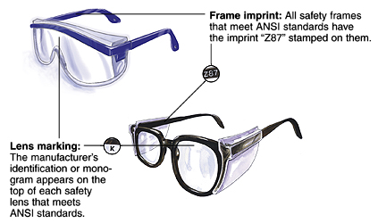
Lenses: Safety glasses that meet ANSI standards have glass or polycarbonate lenses. They are stronger than street-wear lenses, are more impact-resistant, and come in prescription and nonprescription (Plano) forms. Lenses are divided into two protection levels: "Basic Impact" and "High Impact" protectors. These two new levels of protection have distinct testing and marking requirements. Basic impact lenses are tested using a "drop-ball" test, while high impact lenses, and all frames, have to meet the more stringent high mass and high velocity impact tests. High Impact lenses must pass “high velocity” testing where 1/4" steel balls are “shot” at different velocities.
Ensure your safety glasses fit properly. Eye and bridge size and temple length all vary. Frames intended to hold prescription lenses are to be marked "Z87-2". Safety glasses should be individually assigned and fitted. Wear safety glasses so that the temples fit comfortably over the ears. The frame should be as close to the face as possible and supported by the bridge of the nose.
The best safety glasses are the ones the employee will consistently wear!

