Recognizing a Drowning Victim

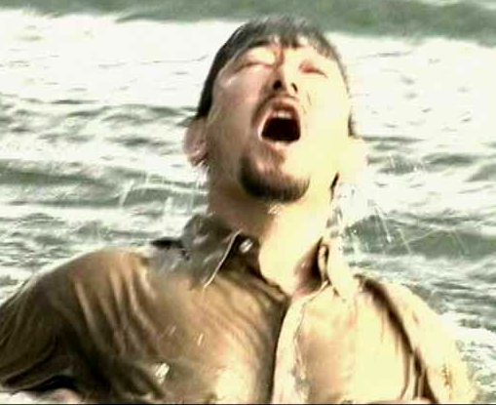
Drowning occurs rapidly and soundlessly, averaging 20 seconds. Most people who die in aquatic accidents - boating/ swimming - succumb to drowning. Most drowning result from three major factors: 1. Inability to swim; 2. effects of relatively cold water, and 3. alcohol.

Drowning, or fatal suffocation in water, is the third most common cause of accidental death in the US, causing almost 8,000 deaths each year and 2nd most common cause in children ages 1-14 yr. To the uninitiated a drowning person's surface struggle may appear to be playing, clowning or splashing accompanied by lack of requests for help. Simply observing and reacting to the signs of drowning by basic, shore-based reaching or throwing rescues may cancel a needless tragedy.

Most drowning occurs 10 feet or less from safety, and roughly 60 % of the time another person is both witnessing and in a position to rescue the victim. Unfortunately, would-be rescuers are not aware of the classic signs of drowning.

Drowning typically begins with a panic or struggle that is followed by a submission to the situation. The victim often swallows a great deal of water before passing out. Within 3 minutes of being underwater, the victim loses consciousness. After 5 minutes underwater, the victim suffers brain damage. This signals the heart to go into an irregular rhythm and eventually stop beating. Signs or behaviors associated with drowning or near-drowning include:

- Head low in the water, mouth at water level
- Head tilted back - mouth open
- Eyes glassy and empty, unable to focus
- Eyes open, with fear evident on the face
- Hyperventilating or gasping
- Uncontrollable movement of arms and legs, rarely out of the water.

Drowning victims are probably the most dangerous to try to rescue. In a panic, drowning victims are likely to claw at rescuers and climb to the surface at all costs. NEVER attempt a direct rescue of a conscious drowning victim without proper training. If nothing will reach, throw the victim a rope and encourage him or her to grab on. A life-preserver with a rope attached is a very good option. Remember always: REACH, THROW, but only GO with training and equipment.

